Key Concepts
SSL Certificate
  - An SSL certificate is a data file hosted in a website's origin server (main webserver apart from edge/caching servers). SSL certificates make SSL/TLS encryption possible, and they contain the website's public key and the website's identity, along with related information.
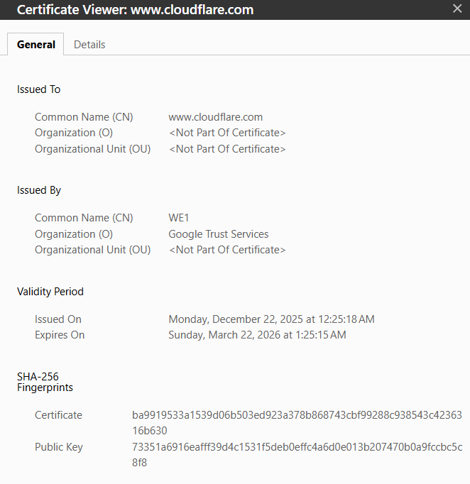
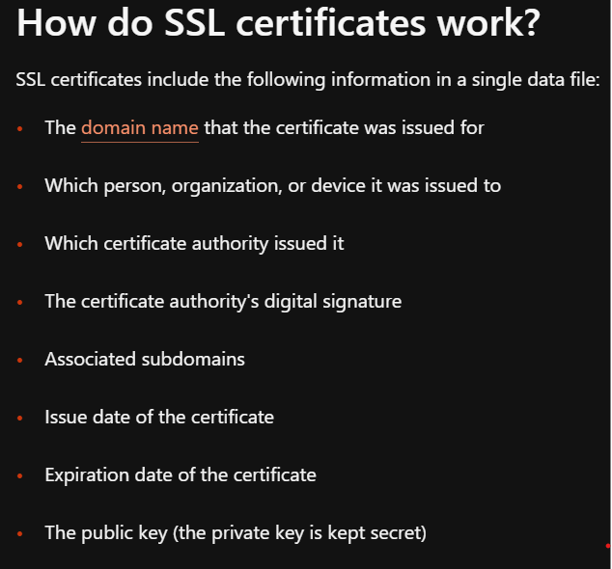

  - A Certificate Authority (CA) validates and signs certificates (with CA’s own private key so clients can verify it later with CA public key) to ensure authenticity. There are different levels of validation, ranging from bare minimum validation to thorough background investigations. An SSL certificate from any of these validation levels provides the same degree of TLS encryption; the only difference is how thoroughly the CA has authenticated the organization's identity. Once the certificate is issued, it needs to be installed and activated on the website's origin server. Technically, anyone can create their own SSL certificate by generating a public-private key pairing and including all the information mentioned above. Such certificates are called self-signed certificates because the digital signature used, instead of being from a CA, would be the website's own private key. But with self-signed certificates, there's no outside authority to verify that the origin server is who it claims to be. Browsers don't consider self-signed certificates trustworthy and may still mark sites with one as "not secure," despite the https:// URL.
  - The client also authenticates itself to the server with a client certificate if/when requested.
Types of Certificates:
Single Domain SSL Certificates applies to one domain and one domain only. It cannot be used to authenticate any other domain, not even subdomains of the domain it is issued for.
Wildcard SSL certificates are for a single domain and all its subdomains. A subdomain is under the umbrella of the main domain.
Multi-domain SSL certificate, or MDC, lists multiple distinct domains on one certificate. With an MDC, domains that are not subdomains of each other can share a certificate.
Types of validations:
Domain Validation is the least-stringent level of validation and cheapest. To obtain one of these SSL certificates, an organization only has to prove they control the domain. They can do this by altering the DNS record associated with the domain, or sometimes just by sending the CA an email.
Organization Validation involves a manual vetting process: The CA will contact the organization requesting the SSL certificate, and they may do some further investigating.
Extended Validation involves a full background check of the organization. The CA will make sure that the organization exists and is legally registered as a business, that they actually are present at the address they list, and so on.

Types of Certificates in Kubernetes
  - Client Certificates: Used by clients (e.g., users/admins, kubelet, kubectl, controller manager, scheduler) to prove its identity to servers.
  - Server Certificates: Used by the server (API server, etcd, kubelet) to prove its identity to clients (kubectl, kubelets, controllers).
  - Root Certificates: Used by the Certificate Authority (Cluster CA, Front-proxy CA) to sign and validate other certificates. Cluster CA is root of trust for all other certificates in cluster.
- Certificate Authority Role
  - The CA uses its own public/private key pair to sign server and client certificates.
  - The CA’s public certificate is installed in clients to validate server certificates.

SSL/TLS Communication in Kubernetes Cluster
- A Kubernetes cluster has a master node (with API server and control plane components) and multiple worker nodes.
Secure communication is required between:
  - User (client) and Kubernetes API server (server).
  - API server (client) and worker node components like Kubelet (server).
  - Various master node components (e.g., scheduler, controller manager) and the API server.
Role Reversal in Communication:
  - When a user interacts with the API server, the user is the client and API server is the server.
  - When API server communicates with worker node components like Kubelet, the API server acts as the client, and the Kubelet is the server.
- Every communication channel requires both client and server certificates for mutual TLS authentication. Roles flip depending on the direction of communication. Example -
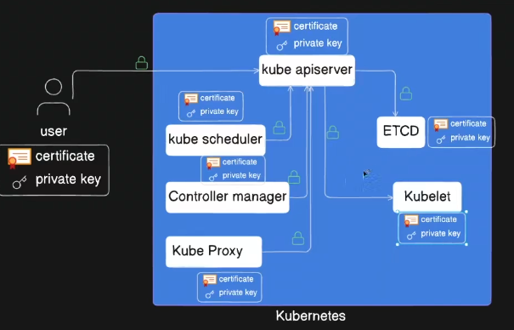
Kubelets use mutual TLS with the API server: As clients (registering, reporting status); As servers (serving logs, metrics).

Certificate Naming Conventions and File Types
File Type | Naming Convention Example | Description
Public Certificate | server.crt, client.pem | Certificate file (public)
Private Key | server.key, client-key.pem | Private key file (keep secret)
- Rule of thumb: File names or extensions containing "key" indicate a private key; others are public certificates.

Practical Steps: Creating and Approving a Certificate Signing Request (CSR) in Kubernetes – Scenario: new user joins team and needs access to cluster
- User Generates Private Key and CSR
  - Use OpenSSL to create a private key (rk.key).
openssl genrsa -out rk.key 2048
  - Generate a CSR (rk.csr) using the private key.
Openssl req -new -key rk.key -out rk.csr -subj “/CN=rk/O=developers”
CN → Common Name (username in Kubernetes).
O → Organization (maps to Kubernetes group, e.g., developers).
- Administrator Creates Kubernetes CSR Object
  - Create a Kubernetes CSR manifest YAML file embedding the base64-encoded CSR, without any line breaks.
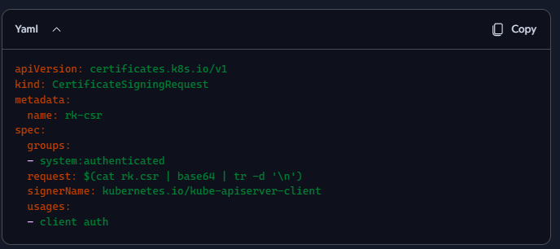
Can optionally define expiration time.
- Apply the CSR Object to Kubernetes
  - Use kubectl apply -f csr.yaml to create the CSR in Kubernetes.
  - Initially, the CSR status is Pending, as seen with - kubectl get csr
- Admin Approves the CSR
  - Admin verifies the CSR details (kubectl describe csr rk-csr).
  - Approve using kubectl certificate approve rk-csr.
  - The certificate is approved by authorised CA, in this case internal CA hosted on master server by default. Every Kubernetes cluster has a Certificate Authority (CA), usually created when the cluster is bootstrapped (e.g., by kubeadm). CA has its own public certificate and private key. This CA is the root of trust: it signs all server and client certificates used inside the cluster (API server, kubelets, etcd, controllers). The API server is configured to trust this CA and to use it for signing approved CSRs. The CA’s private key and certificate are stored on the control plane nodes, typically under: /etc/kubernetes/pki/ca.crt ; /etc/kubernetes/pki/ca.key
  - A cluster administrator (or any user with RBAC permission to approve CSRs) can use “kubectl certificate approve“. User certificate gets issued and status changes to Approved. This approval doesn’t sign the certificate directly — it tells the Kubernetes controller manager to use the cluster’s CA to sign the CSR. The signed certificate is then placed back into the CSR object’s .status.certificate field. Signer = controller manager, using the CA private key. Approver = cluster admin (or any RBAC-authorized user) who runs kubectl certificate approve.
  - only trusted administrators can allow new identities into the cluster.
  - If you use kubeadm(lightweight command-line tool for bootstrapping minimum viable Kubernetes clusters on existing infrastructure), it generates this CA automatically. If you use a managed service (like EKS, GKE, AKS), the provider manages the CA behind the scenes.
- Retrieve and Decode the Issued Certificate
  - Export the issued certificate from the Kubernetes CSR object. Decode the base64 encoded certificate and share with the user.
kubectl get csr rk-csr -o jsonpath='{.status.certificate}' | base64 --decode > rk.crt
Now you have:
rk.key → private key
rk.crt → signed certificate
- User Updates kubeconfig and Access Permissions
  - Involves adding the certificate to kubeconfig and setting RBAC roles for user access.
kubectl config set-credentials rk --client-certificate=rk.crt --client-key=rk.key
kubectl config set-context rk-context --cluster=my-cluster --namespace=default --user=rk
kubectl config use-context rk-context
  - This lets you use kubectl as the new user rk. Now RBAC roles can be used to grant this user permissions.

Kubernetes Components and Their Certificates
Kubernetes Component | Role in Communication | Certificate Type Needed
User (kubectl client) | Client to API Server | Client certificate (user cert)
API Server | Server to User (client) | Server certificate
API Server | Client to Worker Nodes (e.g., Kubelet) | Client certificate (can reuse or generate new)
Kubelet (Worker Node) | Server to API Server | Server certificate
Scheduler, Controller Manager, Proxy | Client to API Server | Client certificates
API Server (interaction with etcd) | Client to etcd (server) | Client and server certificates

Important Insights
- Mutual TLS (mTLS) is critical in Kubernetes for securing all internal and external communications.
- Each Kubernetes component, client, or user requires proper certificates issued and approved by a CA.
- Kubernetes has a built-in certificate API to manage certificate requests and approvals.
- The process involves generating private keys and CSRs on the client side, submitting the CSR to Kubernetes, and then admin approval.
- Base64 encoding of CSRs and certificates is essential for embedding them in Kubernetes manifests.
- User access management via certificates is tied to RBAC and kubeconfig

Best Practices
- Rotate certificates regularly (kubeadm handles this automatically).
- Encrypt Secrets at rest in etcd.
- Use RBAC + certificates for strong authentication and authorization.
- Consider external CAs or secret managers for production clusters.

